November 5, 2015

Governor Jay Nixon:
As you continue to move forward on your own with a stadium financing plan, it is important to clarify the position of leadership of the Missouri House of Representatives, as well as a broad bipartisan cross-section of our membership. St. Louis is, and should remain, an NFL city. However, regardless of our desire to see the Rams remain in St. Louis, we will oppose any proposal that undermines the authority of the Missouri General Assembly and the will of the people. As both the chairman and the vice chairman of the House Budget Committee have made clear, we will not stand idly by as the people of this state are committed to millions of dollars in debt without proper legislative approval or a public vote.
We find it both confusing and troubling that the General Assembly has been excluded from any conversation involving the commitment of state funds to the financing of a new stadium. We would remind you that the Constitution of Missouri exclusively vests the authority to appropriate money with the legislature. We strongly urge you to consider this before continuing upon any path that seeks to circumvent the people of this state and their elected representatives. While my colleagues and I hold the state’s triple-A credit rating in the highest regard, the consequences of forcing the General Assembly to choose between jeopardizing the State’s triple-A credit rating and funding poor public policy with hundreds of millions of dollars of debt payments with no public input will be disastrous.
Historically, both the legislature and the citizens of this state have shown immense support for our NFL franchises. Missouri is very proud of its NFL franchises and has invested more than $350 million dollars in funding for the Jackson County Sports Complex in Kansas City and the Edward Jones Dome in St. Louis over the last 25 years. However, this loyal support is now being sorely tested by a process that has been conducted in secret, even as we continue to pay debt service on the Edward Jones Dome for the next six years.

It is time for public debate upon this issue. This debate is not about the cultural or civic significance that the NFL brings. This debate is about the commitment of hundreds of millions of taxpayers’ dollars and decades of debt obligations by the state. Such a commitment cannot and should not be taken lightly; nor should it be made behind closed doors and out of the public’s eye.
We call upon you to begin operating in good faith with the legislature and the people of Missouri. For the sake of the citizens of the state of Missouri, your fans, and your customers, we invite you, Rams ownership, and the National Football League to work with the General Assembly, just as you have in the past.
The St. Louis Rams have become an integral part of Missouri’s sports history and community. We are a diverse state, comprised of two major metropolitan areas, millions of acres of rural communities, and a great level of enthusiasm for all of our professional and collegiate sports teams. We are a state that respects the rule of law, and are known for our healthy ‘Show-Me’ skepticism. With that in mind, the time has come for an open and transparent dialogue regarding the future of Missouri’s professional sports landscape, and Missourians will not place their full faith and credit in any process that commits taxpayer financing while failing to respect our Constitution and the rule of law.
Sincerely,

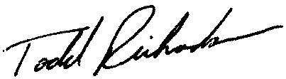

Todd Richardson
District 152

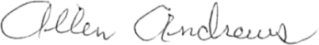
Allen Andrews
District 1
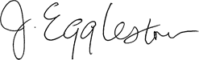

J. Eggleston
District 2
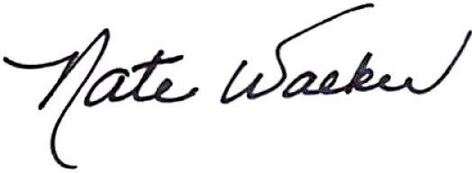

Nate Walker
District 3
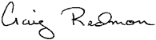

Craig Redmon
District 4
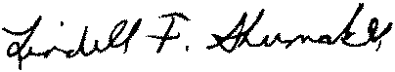

Lindell Shumake
District 5

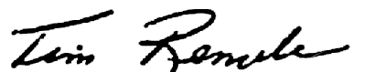

Tim Remole
District 6
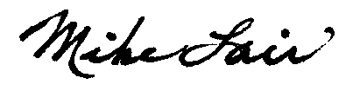

Mike Lair
District 7
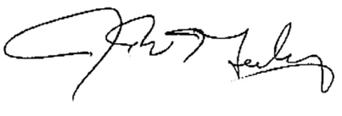

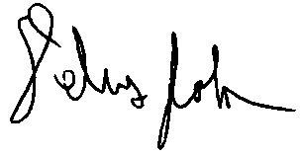
Jim Neely
District 8

Delus Johnson
District 9
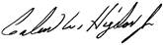

Galen Higdon
District 11
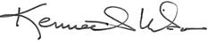

Kenneth Wilson
District 12

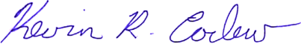
Kevin Corlew
District 14

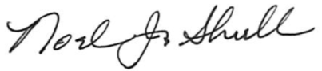
Noel J Shull
District 16
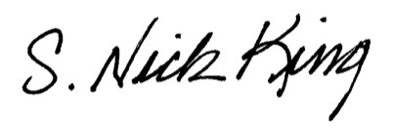

Nick King
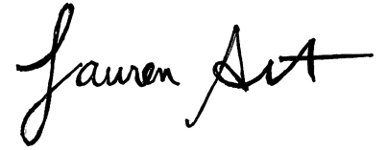
District 17

Lauren Arthur
District 18
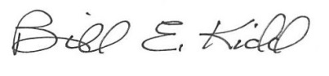

Bill E. Kidd
District 20
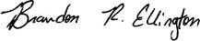

Brandon Ellington
District 22

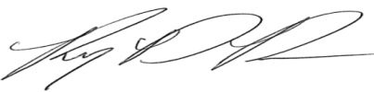

Randy Dunn
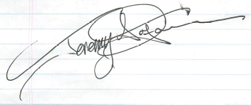
District 23

Jeremy LaFaver
District 25
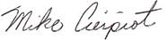

Mike Cierpiot
District 30

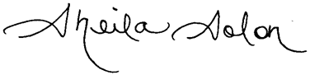
Sheila Solon
District 31
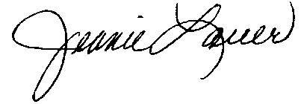

Jeanie Lauer
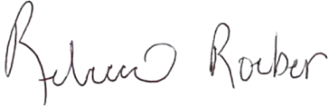
District 32

Rebecca Roeber
District 34

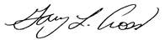
Gary L. Cross
District 35
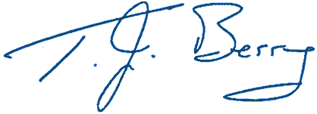

T.J. Berry
District 38
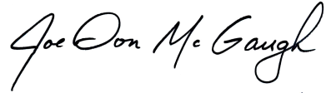

Joe Don McGaugh
District 39

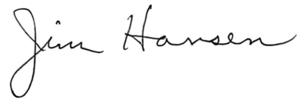
Jim Hansen
District 40
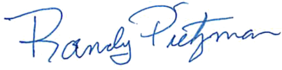

Randy Pietzman
District 41

Bart Korman
District 42
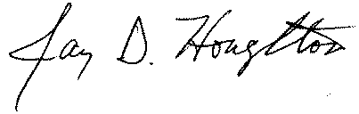

Jay Houghton
District 43
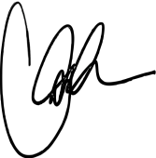

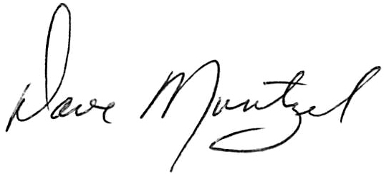
Caleb Rowden
District 44

Dave Muntzel
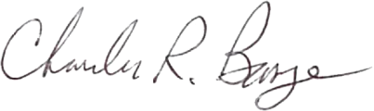
District 48

Charles Basye
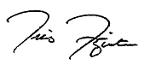
District 47

Travis Fitzwater
District 49

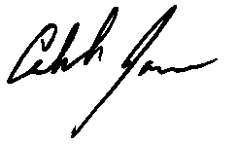
Caleb Jones
District 50

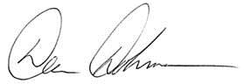
Dean Dohrman
District 51

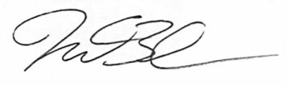
Nathan Beard
District 52
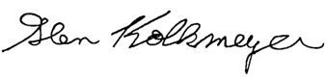

Glen Kolkmeyer
District 53
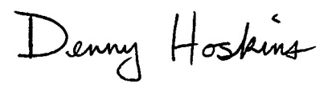

Denny Hoskins
District 54
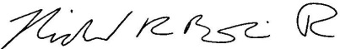

Rick Brattin
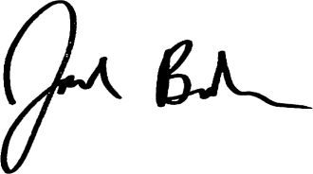
District 55

Jack Bondon
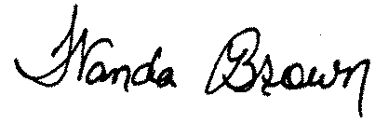
District 56

Wanda Brown
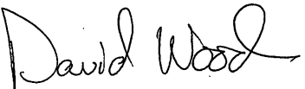
District 57

David Wood
District 58
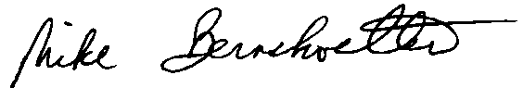

Mike Bernskoetter
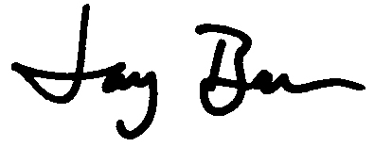
District 59

Jay Barnes
District 60

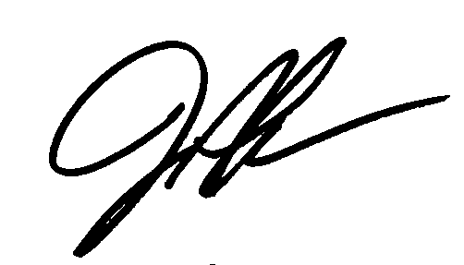
Justin Alferman
District 61

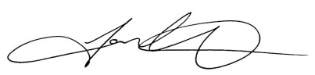
Tom Hurst
District 62

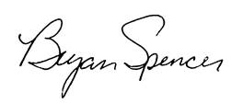
Bryan Spencer
District 63
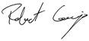

Robert Cornejo
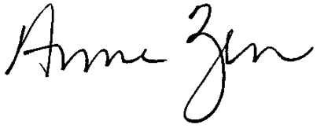
District 64

Anne Zerr
District 65
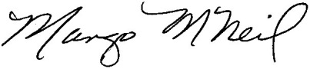

Margo McNeil
District 69

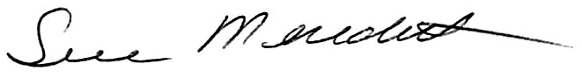
Sue Meredith
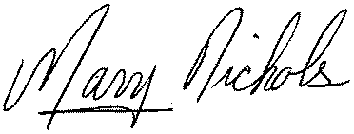
District 71

Mary Nichols
District 72
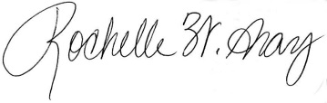

Rochelle Walton Gray
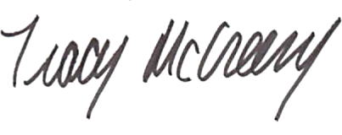
District 75

Tracy McCreery
District 88
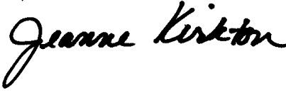
Jeanne Kirkton
District 91

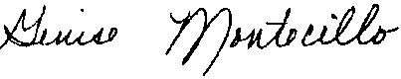
Genise Montecillo
District 92

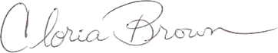
Cloria Brown
District 94

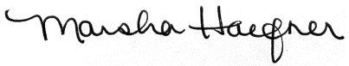
Marsha Haefner
District 95
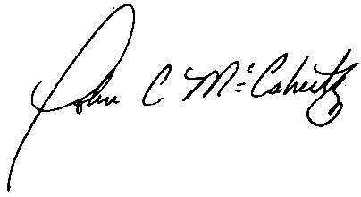
John McCaherty
District 97
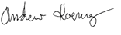

Andrew Koenig
District 99
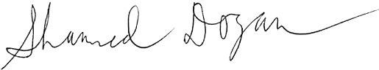

Shamed Dogan
District 98
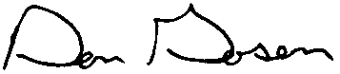

Don Gosen
District 101

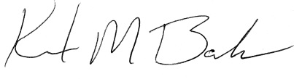
Kurt Bahr
District 102
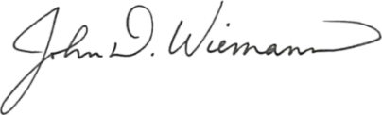

John Wiemann
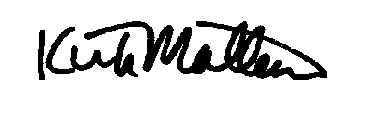
District 103

Kirk Mathews
District 110
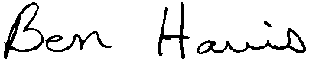

Ben Harris
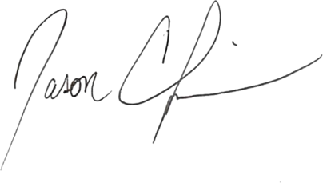
District 118

Jason Chipman
District 120

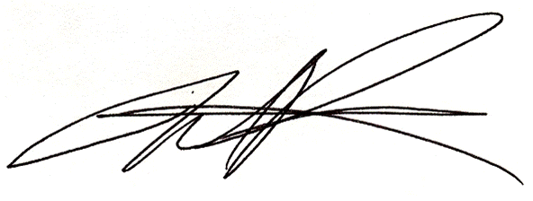
Mark Parkinson
District 105

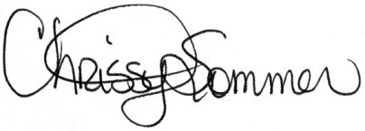
Chrissy Sommer
District 106

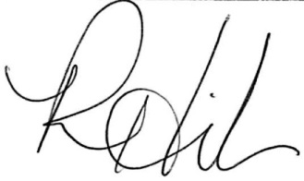

Ron Hicks
District 107
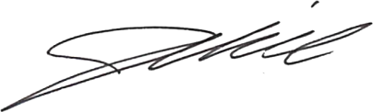
Justin Hill
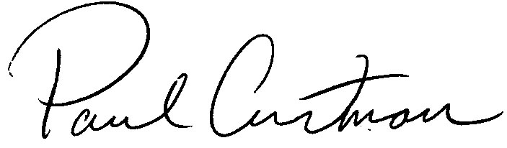
District 108

Paul Curtman
District 109

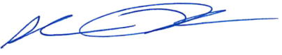
Shane Roden
District 111

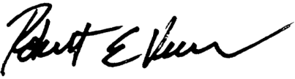
Robert Vescovo
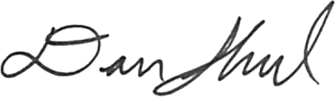
District 112

Dan Shaul
District 113

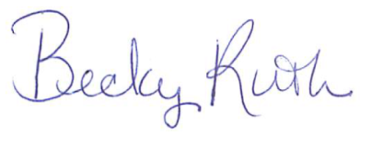
Becky Ruth
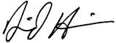
District 114

Dave Hinson
District 119
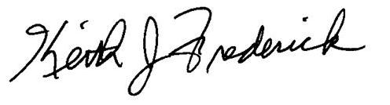

Keith Frederick
District 121
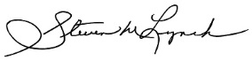
Steve Lynch
District 122

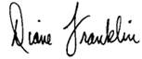
Diane Franklin
District 123

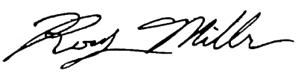
Rocky Miller
District 124

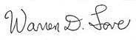

Warren Love
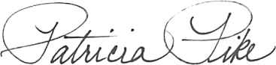
District 125

Patricia Pike
District 126

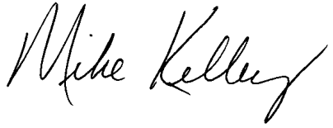
Mike Kelley
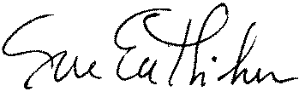
District 127

Sue Entlicher
District 128
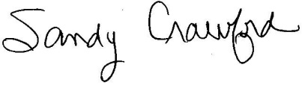
Sandy Crawford
District 129

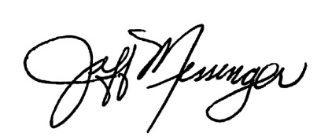
Jeffrey Messenger
District 130
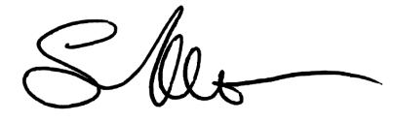

Sonya Anderson
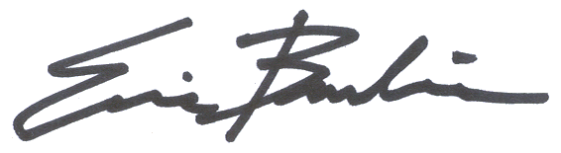
District 131

Eric Burlison
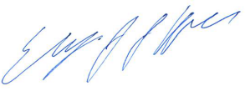
District 133

Elijah Haahr
District 134

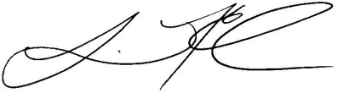
Lincoln Hough
District 135

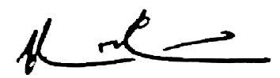
Kevin Austin
District 136

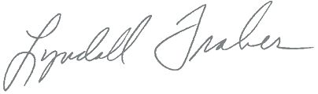
Lyndall Fraker
District 137
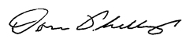

Don Phillips
District 138

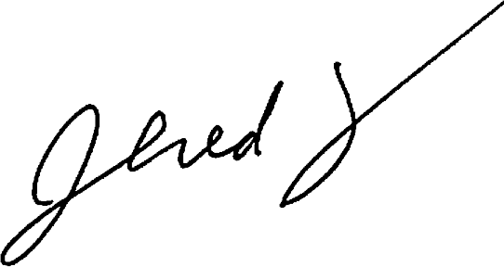
Jered Taylor
District 139

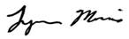
Lynn Morris
District 140

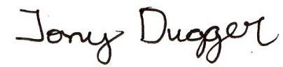
Tony Dugger
District 141

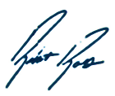
Robert Ross
District 142

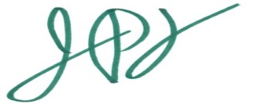
Jeff Pogue
District 143
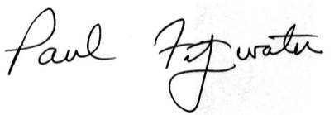

Paul Fitzwater
District 144
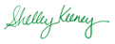

Shelley Keeney
District 145
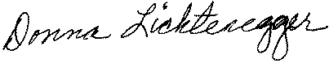

Donna Lichtenegger
District 146

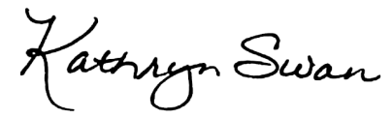
Kathryn Swan
District 147

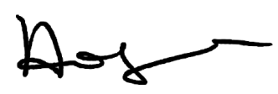
Holly Rehder
District 148

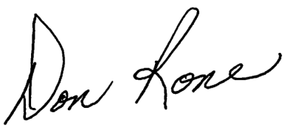

Don Rone
District 149

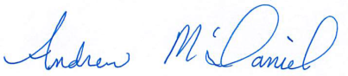
Andrew McDaniel
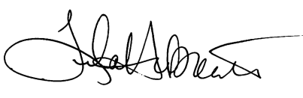
District 150

Tila Hubrecht
District 151
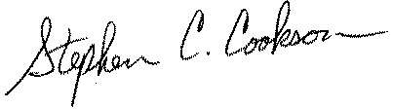
Steve Cookson
District 153

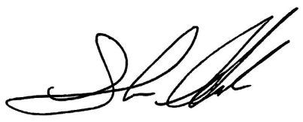
Shawn Rhoads
District 154

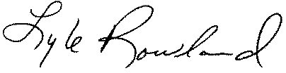
Lyle Rowland
District 155

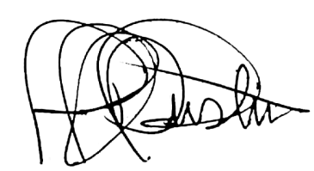
Jeffery Justus
District 156
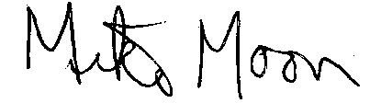

Mike Moon
District 157
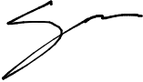

Scott Fitzpatrick
District 158

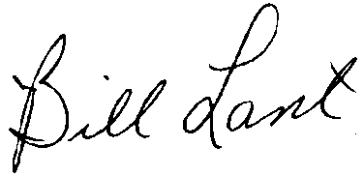
Bill Lant
District 159

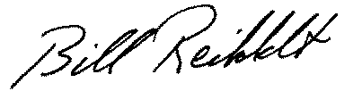
Bill Reiboldt
District 160

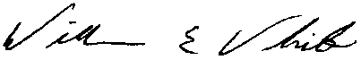
Bill White
District 161
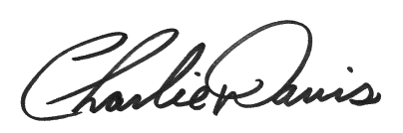

Charlie Davis
District 162

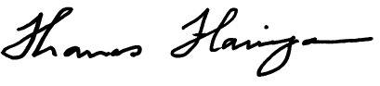
Tom Flanigan
District 163

